
Visit www.amoymagic.com (Guide to Xiamen and Fújiàn)
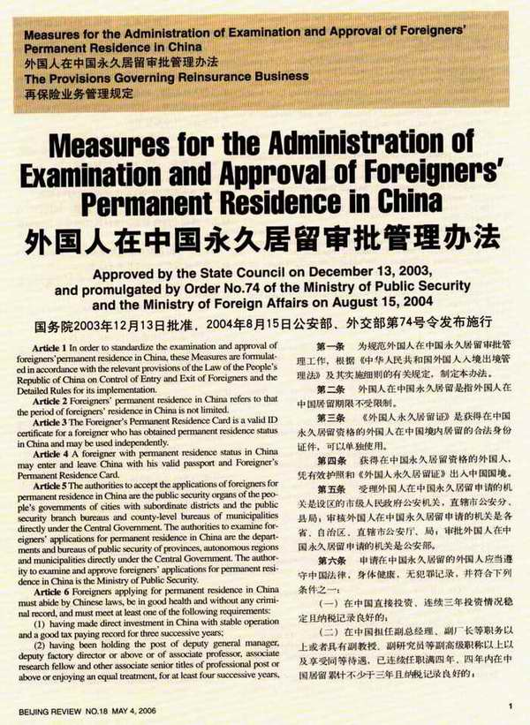
This was taken from Běijīng Review, May 4, 2006, by Dr. Bill, who was first to get PR in Fújiàn Province (in 1992). Back then there was no real procedure for it; today it’s still not easy, but there is a clear process. We need more longterm Lǎowài in China—so go for it!
Enjoy Amoy!

www.amoymagic.com

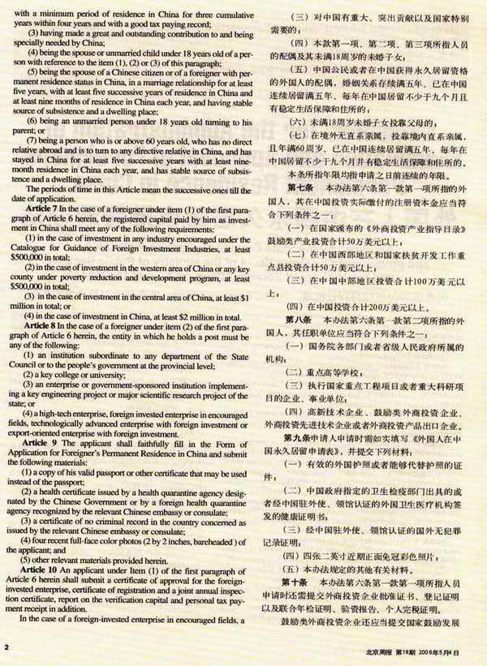

www.amoymagic.com
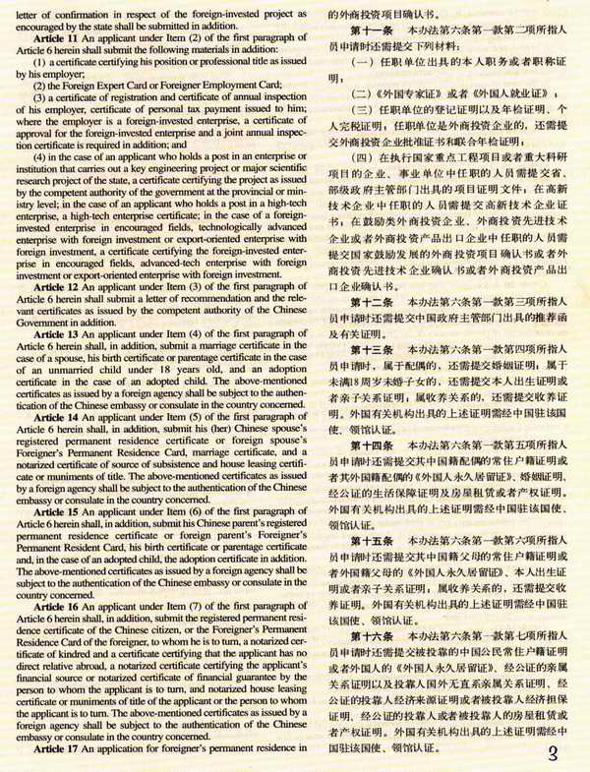

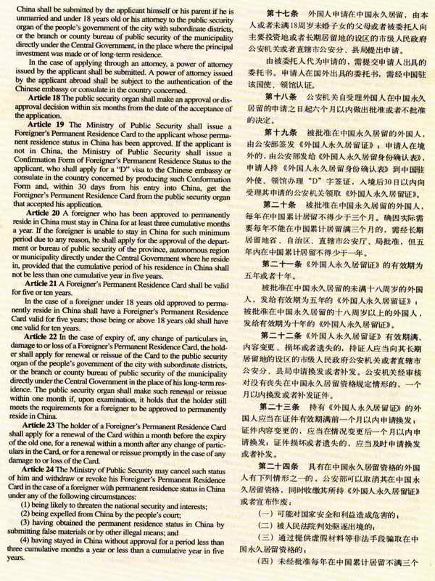
www.amoymagic.com

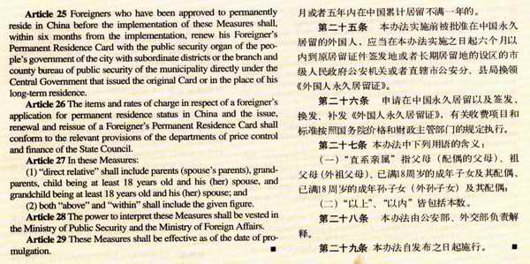
Visit www.amoymagic.com Guide to Xiamen and Fujian

